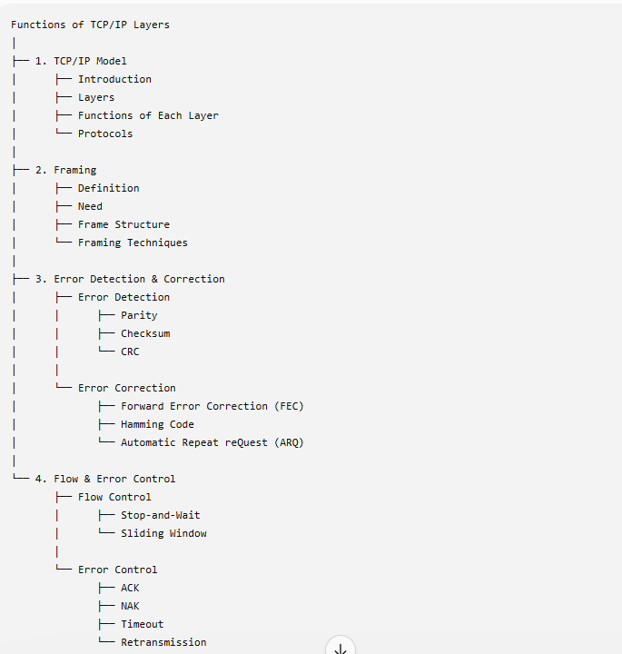
Framing in Data Link Layer
Definition
Framing is the process of dividing a continuous stream of bits into frames, which are the basic units of data transmission in the Data Link Layer (DLL) of the OSI model.
A frame contains:
- User data (payload)
- Source and destination addresses
- Error detection information (CRC/Checksum)
- Control information
Why is Framing Needed?
- Identifies the start and end of each frame.
- Provides source and destination addressing.
- Supports error detection and correction.
- Ensures reliable and synchronized communication.
- Makes data transmission organized and efficient.
Note: Framing is completely handled by the Data Link Layer and is transparent to the user.

Types of Framing
1. Fixed-Size Framing
Definition
All frames have the same predefined size.
Characteristics
- No start or end delimiters are required.
- Frame boundary is identified by its fixed length.
Advantages
- Simple implementation.
- Easy synchronization.
- Faster processing.
Disadvantages
- Causes internal fragmentation when the data is smaller than the frame size.
- Wastes bandwidth.
Solution
Padding is added to fill the unused space.

2. Variable-Size Framing
Definition
Frames can have different sizes depending on the amount of data.
Frame boundaries are identified using:
- Length Field
- End Delimiter (Flag)

(a) Length Field Method
The frame contains a length field that specifies the size of the frame.
Example
| Header | Length = 50 Bytes | Data | CRC |
Advantage
- Easy to determine frame size.
Disadvantage
- If the length field is corrupted, the receiver cannot determine the frame boundary correctly.

(b) End Delimiter Method
A special bit or byte pattern marks the end of the frame.
Example:
Flag = 01111110
Problem:
The same pattern may appear inside the actual data.
Solution:
Use Stuffing Techniques.

Example Without End Delimiter
Assume two frames are transmitted.
Frame 1
11001010
Frame 2
10101111
Without any delimiter, the transmitted data becomes:
1100101010101111
The receiver receives:
1100101010101111
It cannot determine:
- Where Frame 1 ends.
- Where Frame 2 starts.

Example With End Delimiter
Suppose the End Delimiter (ED) is
1111
The sender transmits:
Frame 1 : 11001010 1111
Frame 2 : 10101111 1111
The transmitted bit stream becomes:
11001010 1111 10101111 1111
At the Receiver
The receiver reads bits continuously.
11001010 1111
When it encounters 1111, it understands:
Frame 1 has ended.
Then it continues reading:
10101111 1111
Again, 1111 indicates:
Frame 2 has ended.
Thus, the receiver correctly separates the frames.

Problem with End Delimiter
Suppose the delimiter is
ED = 1111
Now the actual data itself contains 1111.
Example:
Data = 101111001
If the sender simply transmits
1011110011111
the receiver sees:
1011110011111
When it reads the first 1111 inside the data, it mistakenly assumes:
The frame has ended here!
This is incorrect because those bits belong to the data.

Solution – Bit Stuffing
To avoid confusion, whenever the delimiter pattern appears in the data, the sender inserts an extra bit.
For example,
Delimiter:
1111
Original data:
101111001
After bit stuffing (illustrative):
1011101001
Now the delimiter pattern no longer appears inside the data.
At the receiver:
- The extra stuffed bit is removed (de-stuffing).
- The original data is restored correctly.
- The receiver recognizes the actual 1111 only when it appears as the End Delimiter.

Stuffing Techniques
1. Character (Byte) Stuffing
Definition
Used in character-oriented protocols.
Whenever a special delimiter character appears in the data, an escape character is inserted before it.
Example
Suppose:
Delimiter = $
Escape = \
Original Data
ABC$XYZ
After Byte Stuffing
ABC\$XYZ
Advantages
- Simple to understand.
- Suitable for text-based communication.
Disadvantages
- Extra processing overhead.
- Rarely used in modern high-speed networks.

2. Bit Stuffing
Definition
Used in bit-oriented protocols.
Whenever the delimiter pattern appears in the data, an extra 0 bit is inserted so that the receiver does not confuse it with the frame delimiter.
Example
Delimiter
01111110
Data
01111110
After Bit Stuffing
011111010
The receiver removes the inserted 0 during de-stuffing.
Advantages
- Efficient for binary communication.
- Widely used in modern protocols (e.g., HDLC).

Problems in Framing
- Frame Boundary Detection
  - Receiver must correctly identify the start and end of each frame.
- Synchronization
  - Sender and receiver must remain synchronized during transmission.
- Error Handling
  - Noise may corrupt the frame or delimiters.
  - CRC and checksums are used for error detection.
- Overhead
  - Headers, trailers, and stuffing increase frame size.
- Efficiency
  - Balance between payload size and control information.
- Compatibility
  - Different framing methods may lead to interoperability issues.

Comparison: Fixed vs Variable Framing
Feature | Fixed-Size Framing | Variable-Size Framing
Frame Size | Constant | Varies
Boundary Detection | Frame length | Length field or delimiters
Complexity | Simple | More complex
Efficiency | Lower (padding required) | Higher
Bandwidth Usage | Less efficient | More efficient
Fragmentation | Internal fragmentation | Minimal

Advantages of Framing
- Reliable data transmission.
- Easy error detection.
- Proper synchronization.
- Efficient flow control.
- Organized communication.
- Supports addressing and control information.

